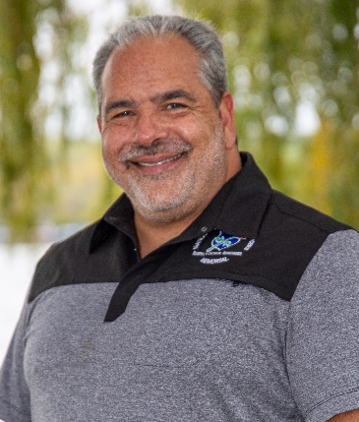

**Biography**

**Eric C. Weaver**

Eric Weaver is a leading expert, advocate, speaker, and instructor on mental health issues, specializing in law enforcement. He is the author of the book, “Overcoming the Darkness: Shining Light on Mental Illness, Trauma, and Suicide in Law Enforcement,” He is also a Master Certified Professional Life Coach by the Certified Life Coach Institute and is a member of the International Coaching Federation.

Eric is a retired sergeant with the Rochester, NY Police Dept., where he served for twenty years from 1985-2005. He was a police sergeant for the RPD for the last 13 years of his highly decorated career. Prior to his employment with the RPD, he served as a Corrections Officer from 1983-1985 with the Ontario County, NY Sheriff’s Department. While with the RPD, he served in numerous positions within the Department, including numerous patrol assignments, the Tactical Unit, the SWAT team, and Internal Affairs. Eric’s last assignment for the Rochester Police Department was as Mental Health Coordinator, and was the creator, developer, and Commanding Officer of the first Crisis Intervention Team in NYS. The CIT is a specialized unit within the RPD that responds to calls within the Rochester community for individuals who are experiencing a mental health crisis. He continues to serve as a consultant with numerous police departments and their respective communities in NYS in the creation, development, training, and implementation of similar Crisis Intervention Teams, and has served as a leading consultant for the NYS Division of Criminal Justice Services and NYS Office of Mental Health in developing CIT training throughout New York State.

In 2008, Eric developed and began directing his own full-time training and consulting business, “Overcoming the Darkness”, in which he provided internationally recognized certification programs, training seminars and keynote addresses on recovery, mental illness, stigmas, communication skills, and suicide awareness, prevention and intervention, for law enforcement agencies, mental health counselors and agencies, hospitals, schools, colleges, and consumer and community groups.

Eric is also a former consultant with the National Council for Mental Wellbeing and served as a National Trainer for the internationally recognized Mental Health First Aid and Youth Mental Health First Aid programs from 2013-2024. He was a contributing writer of the MHFA Public Safety curriculum, specifically regarding officer wellness, Critical Incident Stress, PTSD, police suicide, etc. He is a former Consulting Trainer and Master instructor for ASIST (Applied Suicide Intervention Skills Training), a former SafeTalk (Suicide Alertness Training) instructor, and served as both Area Director and Chair of the Board of Directors for the Western New York Chapter of the American Foundation for Suicide Prevention (AFSP). Eric served as a member of the Board of Directors for the Suicide Intervention Skills Trainer Consortium of New York. He also was a Depression and Bi-Polar Support Alliance’s (DBSA) group facilitator and a member of the DBSA National Speaker’s Bureau and was a member of the National Alliance on Mental Illness (NAMI)-NYS Consumer Affairs Committee. He also serves as a Peer Review consultant for SpecPro Management Services, LLC regarding police mental health training on a state and federal level.

After retirement, while still training on the issues of mental illness and suicide intervention, Eric served as a Peer Advocacy Coordinator for the Rochester Psychiatric Center, and then served as a full time Pastor from 2005-2010 as the Executive, Counseling, and Celebrate Recovery Pastor of a large church in Upstate NY.

Diagnosed with severe mental illness and hospitalized for suicidality on numerous occasions between 1996 and 2023, while serving in roles as a police sergeant, pastor, and training consultant, Eric openly and honestly shares his story with each of his audiences. In 2002, after the suicide death of a fellow RPD officer, he wrote and developed his seminar, ‘Overcoming The Darkness,” a course on mental health, cumulative stress, stigmas, depression, PTSD, suicide prevention and awareness within law enforcement and among officers themselves. Eric has instructed this course to approximately 40,000 law enforcement officers and other emergency services personnel across the country. Due to Eric’s professional and personnel experiences in his work in mental health, he has won numerous awards throughout NYS, and has been featured and quoted nationally in ‘Newsweek’, ‘TIME’, ‘Details’, and ‘Reader’s Digest’ magazines, WebMD, the FBI National Academy Magazine, as well as various news publications and local television programs.